Jennifer Daniel

CIT480

Chapter 7 Exercises

**Exercise 7-1:**

7-1 Part 1-2:

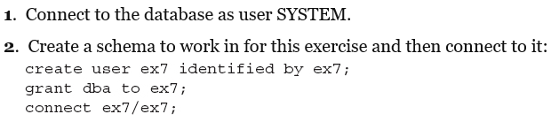

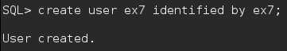

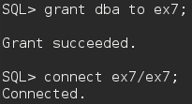

7-1 Part 3:

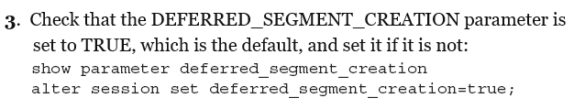

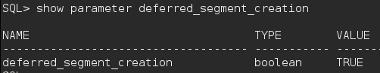

7-1 Part 4:

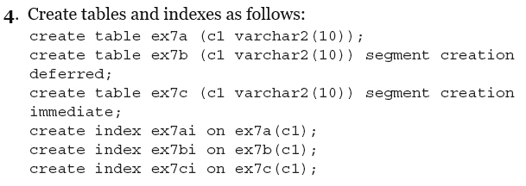

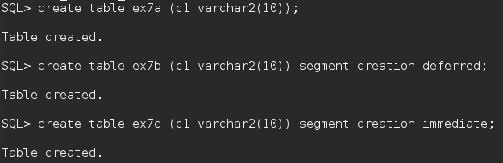

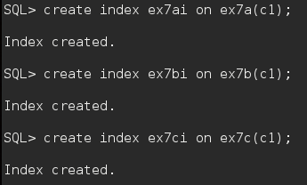

7-1 Part 5:

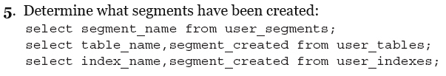

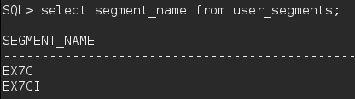

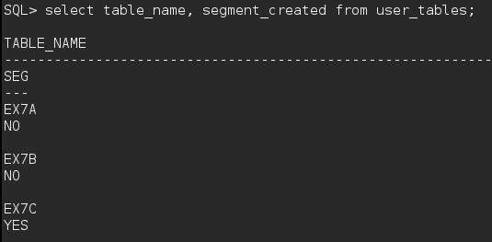

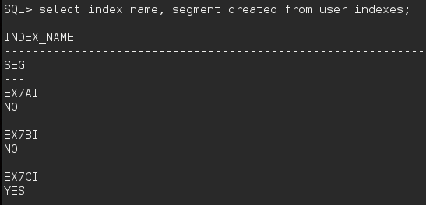

7-1 Part 6:



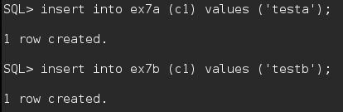

7-1 Part 7:



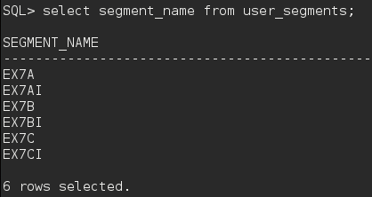

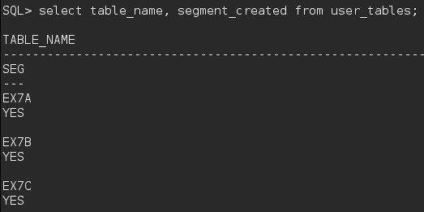

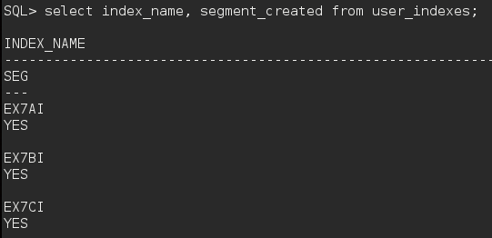

**Exercise 7-2:**

7-2 Part 1-2:

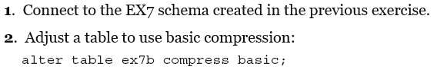



7-2 Part 3:

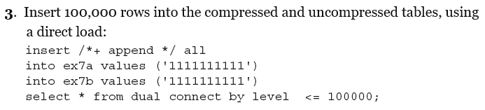

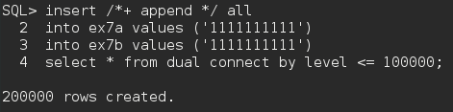

7-2 Part 4:

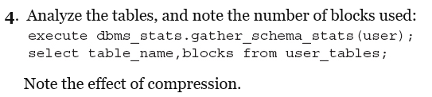

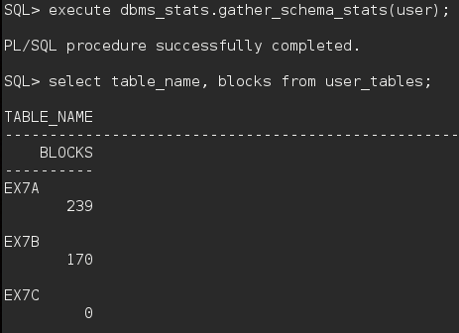

7-2 Part 5:

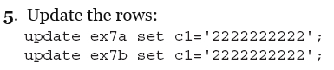

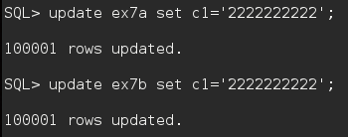

7-2 Part 6:

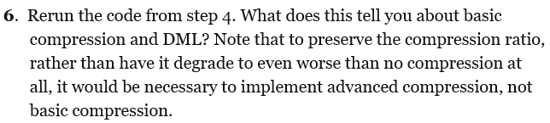

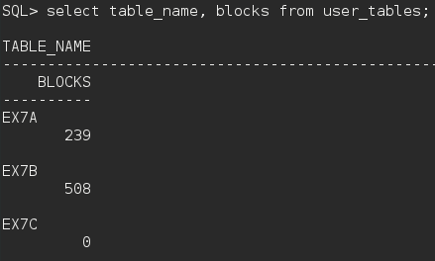

**Exercise 7-3:**

7-3 Part 1:

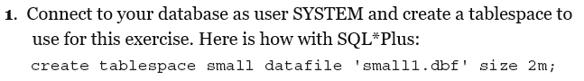



7-3 Part 2:

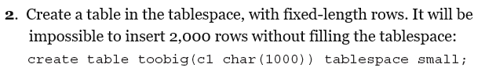



7-3 Part 3-4:

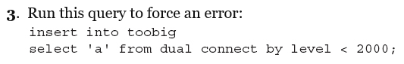



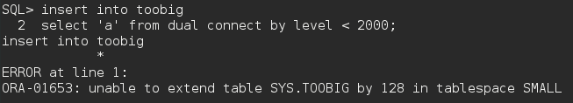

7-3 Part 5:

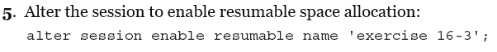

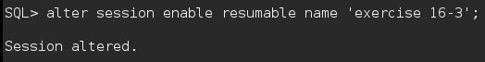

7-3 Part 6:



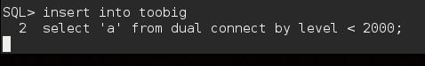

7-3 Part 7:

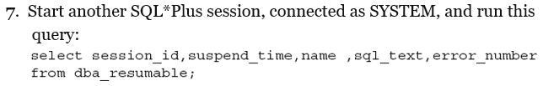

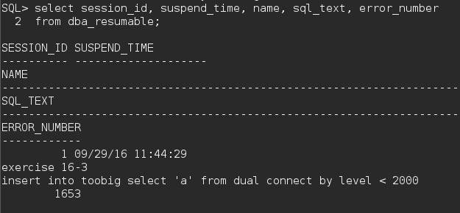

7-3 Part 8:



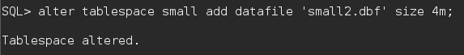

7-3 Part 9:

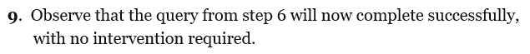

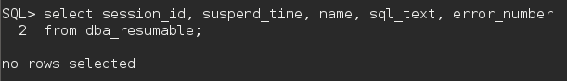

7-3 Part 10:

